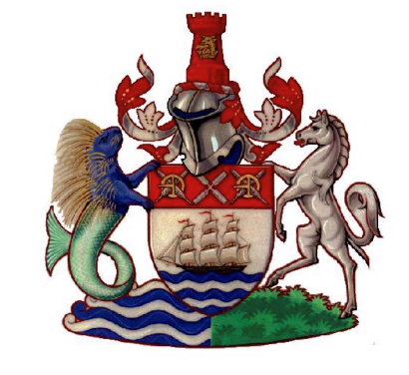

The Worshipful the Mayor of Gravesham - Councillor Alison Williams
"Beating the Bounds" Charity Walk
Saturday 10th and Sunday 11th October 2026

Sponsorship proceeds to: GBC Payment Account – 54599860 – sort code 30-93-60
Reference: Mayor’s Charity Boundary Walk (please email mayorscharity@gravesham.gov.uk when payment made)

OFFICIAL SPONSORSHIP FORM
Estimated distance of boundary: 32 miles: Saturday 16 miles, Sunday 16 miles
All proceeds go to the mayor’s nominated charities

Full Name | Home address  (To be eligible for Gift Aid, please do not give a work address) | Your Postcode | Sponsorship  amount | Date of Donation
John Doe | 123 Street, Town | AB12 3CD | £20 | 01/09/2026

